# https://upload.wikimedia.org/wikipedia/en/f/f1/Capital_University%2C_Jharkhand_logo.png

# CAPITAL UNIVERSITY - KODERMA

POWER PLANT INSTRUMENTATION ASSIGNMENT

Name : Arshad Nazir

Electrical and Electronics Engineering

Signature:

Date :

1. Identify the two important use of surge tank. Ans:
   * Surge tanks are used to measure liquid flow rate and the combined shrinkage and meter factor.
   * They are also used as a second stage separator, and hold a constant back-pressure by using an automatic pressure control valve on the gas outlet.
2. Name the four commonly used moderators in nuclear power plants.

Ans: The moderator slows down the neutrons to thermal energies by collision with inert atoms (scattering).

* + Water
  + Beryllium
  + Graphite
  + heavy water

1. Summarize the functions of two important components of Nuclear power plant Ans:

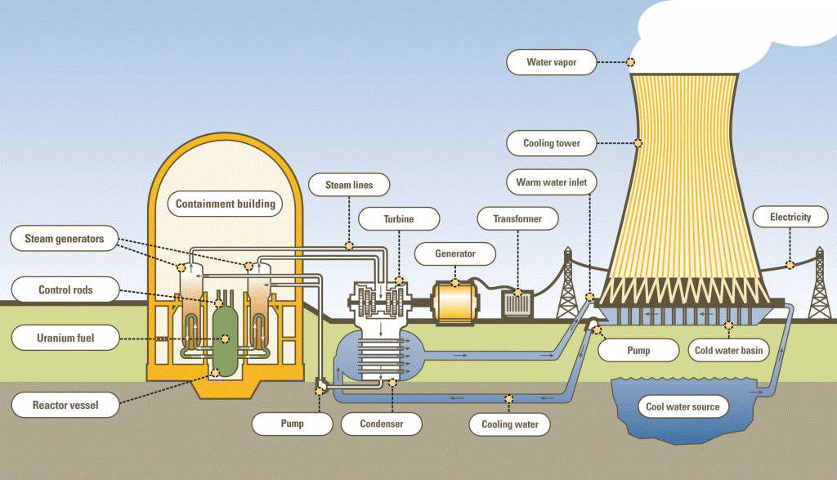

* + Nuclear Reactor. A nuclear reactor is a crucial device of nuclear power plants. The primary purpose of the nuclear reactor is to initiate and control a sustained nuclear chain reaction.
  + Steam Generators. Steam generators are heat exchangers that convert feedwater into steam from heat produced in a nuclear reactor core. They are used in pressurized water reactors (PWR) between the primary and secondary coolant loops.

1. Classify the types of Wind power plant Ans:

* **Remote Wind Power Plants**

Most probably you are sitting in a big city and reading this article from the comfort of your home or office without having any real experience of the power shortage faced in remote parts of the world. Areas which are remote but are blessed with good wind speeds and frequency need a wind turbine which is maintenance free or low-maintenance for long periods of time (just imagine a service technician rushing across mountains and valleys on foot or bullock-cart to repair a turbine time and again). This means that they should have the capability of standing against all odds of climate even if they are relatively smaller in size than their conventional counterparts. These types of turbines are known as remote wind power turbines and are specifically designed with these objectives in view. The picture shows a turbine for such use.

* **Hybrid Wind Power Plants**

Wind is not fully reliable so we cannot depend on wind alone for generation of power. The best bet would be to combine a wind power plant with some other renewable source of energy, like solar energy. That would be certainly a better idea and you can imagine that when there is a lot of heat, the solar generators would do their job and when the sky is overcast and winds are blowing, the wind power plants would take over. Such an arrangement is known as hybrid arrangement and is useful in regions where there is a lot of heat and wind.

* **Grid Connected Wind Power Plants**

This concept is similar to a hybrid system. The wind power plant is used in conjunction with a main grid which supplies most of the power. The main purpose of the wind turbines is to supplement the energy supply for the grid, whereas the main function in the hybrid system is to complement the energy supply, hence the minor difference in the set up

* **Wind Farms**

Unity is strength: a group of people could perform a much bigger task than an individual. This is the concept underlying the wind farms. As the name itself suggests, a wind farm is a collection of wind turbines which collectively power a given area or utility harnessing the wind force in a collective manner thereby amplifying the effect of a single unit.

These configurations are used at various locations depending on the conditions of the region and the presence of other sources of electrical supply. An optimum mix would consist of an ingenious combination of the various sources in the best possible manner.

1. Express about enriched uranium.

Ans: Enriched uranium is a type of uranium in which the percent composition of **uranium- 235** (written 235U) has been increased through the process of isotope separation. Highly Enriched Uranium – contains a 235U concentration greater than 20 percent. Highly enriched uranium (HEU) is used in **naval propulsion reactors, nuclear weapons and in some research**

**reactors**. Uranium can be enriched by separating isotopes of uranium with lasers. Molecules can be excited by laser light; this is called photoexcitation. Lasers can increase the energy in the electrons of a specific isotope, changing its properties and allowing it to be separated.

1. List out the Advantages and Disadvantages of solar power plant. Ans:

|  |  |
| --- | --- |
| **Advantages of Solar Energy** | **Disadvantages of Solar Energy** |
| Reduces Electricity Bills | Weather Dependent |
| Diverse Applications | Solar Energy Storage is Expensive |
| Low Maintenance Costs | Uses a Lot of Space |
| Technology Development | Associated with Pollution |

1. Examine the basic factors to be considered for thermal power plant? Ans:

* Availability of coal.
* Availability of water.
* Transportation facilities.
* Land requirement.
* Load center.
* Away from populated area.
* Ash handling equipment.

1. Differentiate Sub-Critical Power and Super-Critical Power Plant

Ans:

|  |  |  |  |  |  |
| --- | --- | --- | --- | --- | --- |
|  |  | Temperature | Pressure | Drums | Bubble  Formation |
| Subcritical | Subcritical boilers | Subcritical boilers | Subcritical | Subcritical | Bubble |
|  | are boilers that | are operated at | boilers are | boilers are | formation is |
|  | work at | temperatures up | operated at a | composed of | a major |
|  | temperatures up | to 374°C. | pressure of 3,208 | drums. | drawback in |
|  | to 374°C and at a |  | psi. |  | subcritical |
|  | pressure of 3,208 |  |  |  | boilers. |
|  | psi (the critical |  |  |  |  |
|  | point of water). |  |  |  |  |
| Supercritical | Supercritical | Supercritical | Supercritical | Supercritical | There is no |
| Boiler | boiler | boilers are | boilers are | boilers are | bubble |
|  | (supercritical | operated at | operated at a | drum-less. | formation |
|  | steam generator) | temperatures | pressure above |  | supercritical |
|  | is a type of boiler | around 538– | 3,200 psi. |  | boilers. |
|  | that works under | 565°C. |  |  |  |
|  | supercritical |  |  |  |  |
|  | pressure |  |  |  |  |
|  | conditions. |  |  |  |  |

1. Give any two role of air preheater Ans:
   * It is used to extract waste heat from the flue gases leaving the boiler exhaust thereby increasing the efficiency of a boiler by 2-3 %.
   * It is used to preheat the fuel which further increases the boiler efficiency.
2. Differentiate between Renewable and Non-Renewable energy sources. Ans:

|  |  |
| --- | --- |
| **Renewable Resources** | **Non-renewable Resources** |
| Renewable resources cannot be depleted over  time | Non-renewable resources deplete over time |
| Renewable resources include sunlight, water, wind and also geothermal sources such as hot  springs and fumaroles | Non-renewable energy includes fossil fuels such as coal and petroleum. |
| Most renewable resources have low carbon  emissions and low carbon footprint | Non-renewable energy has a comparatively  higher carbon footprint and carbon emissions. |
| The upfront cost of renewable energy is high.  – For instance, Generating electricity using technologies running on renewable energy is  costlier than generating it with fossil fuels | Non-renewable energy has a comparatively lower upfront cost. |

|  |  |
| --- | --- |
| Infrastructure for harvesting renewable energy is prohibitively expensive and not easily  accessible in most countries. | Cost-effective and accessible infrastructure is available for non-renewable energy across  most countries |
| Requires a large land/ offshore area, especially  for wind farms and solar farms | Comparatively lower area requirements |

1. Generalize the essentials of a good steam boiler Ans: A good boiler should posses the following features:
   * It should produce the maximum quantity of steam with the minimum fuel consumption.
   * It should be more economical to install
   * It should be rapid to meet the fluctuation of load
   * It should be capable of quick Starting
   * It should occupy a small floor space
   * The tubes should not be accumulated soot or water deposits.
   * It should be reliable.
   * It should be light weight
   * Its parts or components transportation should be easier.
2. Name the three basic cycle of Thermal Power Plant Ans:

* Rankine Cycle
* Brayton Cycle
* Combined Cycle

1. Discuss the four significant need of instrumentation in power generation.

Ans: Safe and efficient running of the plant is the most important thing. So most modern instruments are used for measuring and process control.

controlling excess air is important to reduce heat loss.

So many trips are provided for the safety of plant and personal. All these is achieved by instrumentation and automation.

THere are lot of parameters to be controlled.

Even chemical factors like silica, oxygen carbon monoxide etc are to be measured and maintained.Turbo generators needs lot of instrumentation .

1. Classify the methods of power generation.

Ans:

* COAL POWER GENERATION
* THERMAL POWER GENERATIONS
* NUCLEAR POWER GENERATION
* HYDRO-POWER GENERATION
* GEOTHERMAL POWER GENERATION
* BATTERY POWER GENERATION
* WIND POWER GENERATION
* WAVES POWER GENERATION
* WASTE WATER & BIO-GAS POWER
* TIDAL POWER GENERATION
* SOLAR POWER GENERATION
* COMBINE CYCLE POWER PLANT & GENERATION

1. Combine Heat and Power System.

Ans: Combined heat and power (CHP) plants use the waste heat from electricity production for heating purposes, normally for district or industrial heating. When biomass is employed as fuel for CHP plants, the availability of a stable and sufficient feedstock supply within a reasonable distance from the plant is essential. The use of biomass in CHP plants is one of the best options for achieving simultaneously increased bioenergy utilization and significant reductions in emissions. Renewable energy sources, mainly biomass, already account for 13% of all fuel inputs to CHP in the older member states. In the new member states the figure is just 1%, indicating that these countries have large unexplored opportunities to increase their use of biomass fuels for CHP.

1. Tell the two primary function of Economizer

Ans: The Economizers are used in Thermal Power Plant.

* These are mechanical devices used to reduce energy consumption to perform a useful work.
* They also help in preheating the fluid.

1. Define the term Cogeneration.

Ans: Cogeneration is defined as the joint production, in a sequential process, of electricity (or mechanical energy) and useful thermal energy, from a single fossil energy source.

1. Point out the two important working principle of Solar Photo Voltaic Cell.

Ans:

* Photo voltaic effect
* Photoresistors

1. List various methods of feed water flow measurement in power plant.

Ans:

* + Mechanical/Turbine Flow Meter
  + Vortex flow meter
  + Ultrasonic flow meter
  + Variable area flow meter
  + Electromagnetic flow meter
  + Thermal/Mass flow meter
  + Paddlewheel flow meter
  + Positive displacement flow meter

1. Classify the types of turbine speed measurement

Ans: Specific speed of a turbine is defined as the speed of a geometrically similar turbine which produces a unit power when working under a unit head.

* + The specific speed of Pelton turbine ranges between 8-30,
  + Francis turbines have specific speed between 50-250,
  + Specific speed of Kaplan lies between 250-850.

1. Explain the principle of Dall tube?

Ans: A combination of Venturi tube and orifice plate, it features the same tapering intake portion of a

venturi tube but has a ‘shoulder’ similar to the orifice plate’s exit part to create a sharp pressure drop. It

is usually used in applications with larger flow rates.

The Dall tube is a shortened version of a Venturi meter, with a lower pressure drop than an orifice plate. As with these flow meters the flow rate in a Dall tube is determined by measuring the pressure drop caused by restriction in the conduit.

The pressure differential is typically measured using diaphragm pressure transducers with digital readout. Since these meters have significantly lower permanent pressure losses than orifice meters, Dall tubes are widely used for measuring the flow rate of large pipe works.

Differential pressure produced by a dall tube higher than venturi tube and nozzle, all of them having same throat diameters.

1. Point out the significance of Stagnation point?

Ans: Stagnation points exist at the surface of objects in the flow field, where the fluid is brought to rest by the object. The Bernoulli equation shows that the static pressure is highest when the velocity is zero and hence static pressure is at its maximum value at stagnation points.

29. What is pulverized coal?

Ans: Pulverized coal is the type of coal which is broken into fine articles. Usually coal is collected as black coloured sedimentary rock and then it is broken into fine particles which is known as pulverized coal. It is used in furnaces to generate thermal energy from it.

1. Name the five sensors used in measuring vibration Ans:
   * Accelerometers (piezoelectric)
   * Velocity Sensor
   * Proximity Probes (capacitance or eddy current)
   * Laser displacement sensors
2. Describe the concept of excess air

Ans: To ensure complete combustion of the fuel used combustion chambers are supplied with excess air. Excess air increase the amount of oxygen to the combustion and the combustion of fuel.

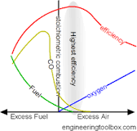

1. List the two basic types of deaerators.

Ans: **Tray-type deaerator** A tray-type deaerator typically has a deaeration section mounted above a horizontal feedwater storage vessel. Water enters the deaeration section into a stainless-steel enclosure through stainless steel spray valves mounted to a horizontal header pipe. During the 1st stage of deaeration, the water is dispersed in a fine film or droplets above a section of trays. The water is deaerated in a 2nd stage, as it cascades downward through openings in the trays. Low-pressure steam enters the enclosure below the trays and flows upward counterflow to the water. The combined action of the 1st and 2nd stages of deaeration guarantees very high performance, as it allows for longer contact time between steam and water. The steam strips the dissolved gases from the boiler feedwater and exits via the vent connection at the top of the vessel. It is critical for proper operation that the vent line be opened sufficiently, or the deaerator will not work properly, causing high oxygen content in the feedwater going to the boilers. The vent line usually includes a valve that allows just enough steam to

escape with the vented gases to provide a small visible telltale plume of steam. The deaerated feedwater flows down into the horizontal storage vessel from where it is pumped to the boiler.

**Spray-type deaerator** A spray-type deaerator is typically a single horizontal vessel which has a preheating section and a deaeration section. The boiler feedwater is sprayed into the preheating section where it is preheated by the saturated environment of the deaerator. The feedwater is heated to its saturation temperature to facilitate the stripping of the dissolved gases in the deaeration section. The preheated feedwater then flows into the deaeration section, where it meets the steam entering the system. The non-condensable gases are stripped out of the water and exit via the vent at the top of the vessel. The deaerated feedwater is pumped from the bottom of the vessel to the boiler.

1. Explain stoichiometric condition of combustion in fuel?

Ans: Stoichiometric combustion is a theoretical position where the optimal amount of oxygen and fuel mix generates the most heat possible, achieving maximum combustion efficiency. There are no unburnt combustibles and no excess air. It is something to strive for, though, in reality, it does not exist.

48. Predict the role of attemperator.

Ans: Attemperator Desuperheaters reduce the steam temperature by combining the superheated steam with water. The steam is cooled through the evaporation of the water. The flow control of water is critical to ensure the correct temperature and pressure are achieved.

1. Quite the need of deaerator control

Ans: Boiler deaerators commonly are used to remove oxygen and other gases from the water that feeds into boilers that generate steam. Deaerators are useful because they remove the gases that attach to the metallic components of the steam system and cause corrosion by forming oxides, or rust. Both oxygen and carbon dioxide are responsible for corrosion, which is why the majority of boiler deaerators are capable of removing oxygen to levels that virtually eliminate carbon dioxide.

1. Examine the role of boiler control.

Ans: Boilers are often the principal steam or hot-water generators in industrial plants. Consequently, they must be designed to operate efficiently and safely while responding rapidly to demand changes. Burner-management systems must be equally adaptive. Control techniques are capable of reducing operating costs while providing greater flexibility in plant management and control.

Tools for burner combustion control generally include

* + regulation of excess air,
  + oxygen trim,
  + burner modulation,
  + air/fuel cross-limiting and
  + total heal control.

1. Give the function of a deaerator in power plant and its importance.

Ans: A deaerator’s job is to remove oxygen and other dissolved gases from boiler feedwater, creating clean, deaerated water. Deaerators are used in industrial applications such as power plants and chemical process industries to reduce corrosion and extend the life of a steam-generating boiler. A deaerator achieves this task by reducing the level of dissolved oxygen and carbon dioxide in the feedwater, which in turn reduces the amount of corrosive compounds within the steam system over time. When the deaerated water exits the deaerator, carbon dioxide concentrations will be zero and dissolved oxygen concentrations will be less than or equal to 7 ppb (parts per billion) (this can be tested through an extraction point). Deaerators also reduce the need for water treatment chemicals, such as an oxygen scavenger,

In addition to reducing dissolved gasses in the feedwater to reduce corrosion damage, a deaerator also raises the temperature of the feedwater before it enters the boiler, thus requiring less fuel for the boiler to heat the water hot enough to produce steam. As a result, the boiler system performs better, is more efficient overall, and helps maintain operating costs.

1. Quote the Steam temperature control methods. Ans:

**BASIC FEEDBACK CONTROL**

The simplest method for controlling steam temperature is by measuring the steam temperature at the point it exits the boiler, and changing the spray water valve position to correct deviations from the steam temperature set point (Figure 1). This control loop should be tuned for the fastest possible response without overshoot, but even then the loop will respond relatively slowly due to the long dead time and time lag of the superheater.

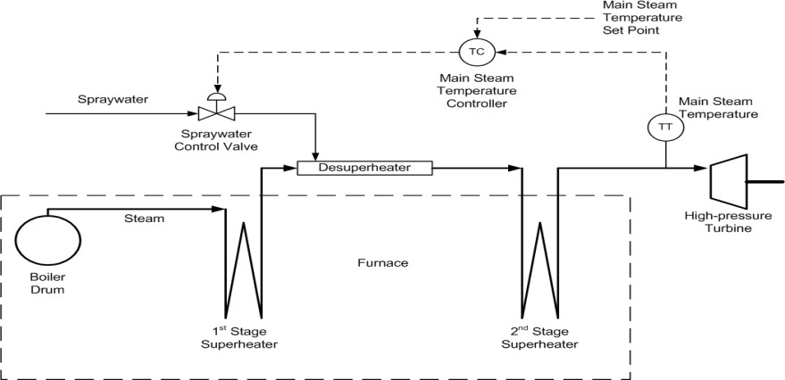 Figure 1.

**CASCADED STEAM TEMPERATURE CONTROL**

Because of the slow response of the main steam temperature control loop, improved disturbance rejection can be achieved by implementing a secondary (inner) control loop at the desuperheater. This loop measures the desuperheater outlet temperature and manipulates the control valve position to match the desuperheater outlet temperature to its set point coming from the main steam temperature controller (Figure 2). This arrangement is called cascade control.

The spray water comes from upstream of the feedwater control valves, and changes in feedwater control valve position will cause changes in spray water pressure, and therefore disturb the spray water flow rate. The desuperheater outlet temperature control loop will provide a gradual recovery when this happens. If the spray water flow rate to the attemperator is measured, a flow control loop can be implemented as a tertiary inner loop to provide very fast disturbance rejection. However, in many cases spray water flow rate is not measured at the individual attemperators and this flow loop cannot be implemented.

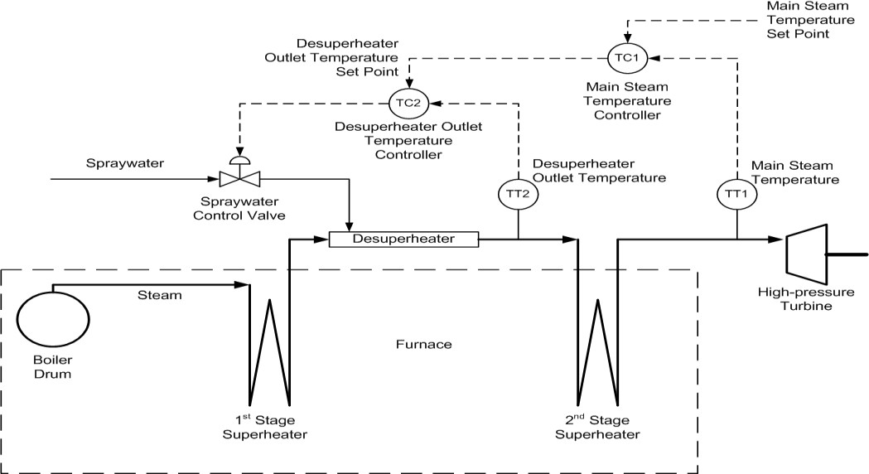Figure 2

**GAIN SCHEDULING**

The process dead time of the superheater increases with a decrease in boiler load because of the slower rate of steam flow at lower loads. This will have a negative impact on the stability of the main steam temperature control loop unless gain scheduling is implemented. Step tests need to be done at low, medium, and high boiler loads, and optimal controller settings calculated at each load level. A gain scheduler should be implemented to adjust the controller settings according to unit load. Because of the changing dead time and lag of the superheater, the integral and derivative times must be scheduled in addition to the controller gain.

The gain of the desuperheater outlet temperature loop will be affected greatly by steam flow rate. Changes in steam flow rate will affect the amount of cooling obtained from a given spray water flow rate. Less cooling will occur at high steam flow rates. In addition, at high loads the pressure differential between the feedwater pump discharge and steam pressure will be lower, reducing the spray flow rate for a given spray valve position (assuming the absence of a flow control loop on the desuperheater spray flow). To compensate for these nonlinear behavior, controller gain scheduling should be implemented on the desuperheater outlet temperature loop too. Fugure 3 shows the basic design of the steam temperature controller gain scheduler (cascaded controller is not shown for clarity). Similar to tuning the main steam temperature control loop, step tests must be done at low, medium, and high boiler loads to design the gain scheduler.

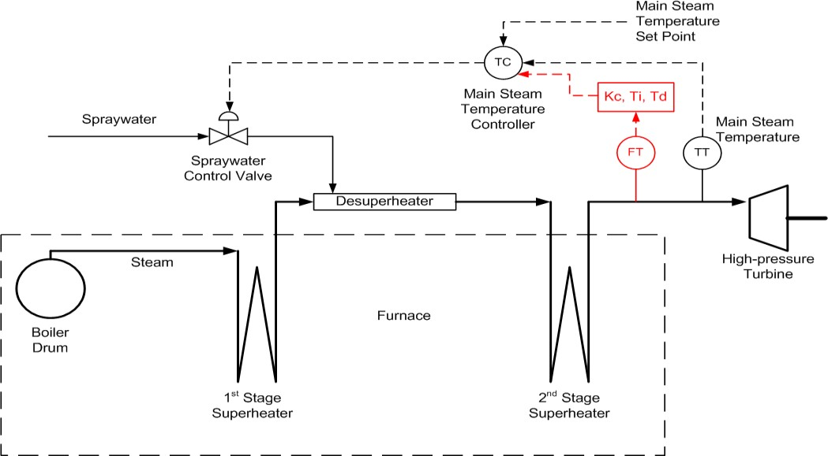

fig 3

**FEEDFORWARD CONTROL**

During boiler load ramps in turbine-following mode, the firing rate is changed first, followed by a change in steam flow rate a while later. With the increase in steam flow rate lagging behind fuel flow rate, the additional heat in the furnace can lead to large deviations in steam temperature. To compensate for this, a feedforward control signal from the boiler master to the steam temperature controller can be implemented.

The feedforward can use the rate of change in fuel flow or one of several other derived measurements to bias the steam temperature controller’s output. In essence, when boiler load is increasing, the spray water flow rate will be increased to counter the excess heat being transferred to the steam, and vice versa. The feedforward can be calibrated by measuring the extent of steam temperature deviation during load ramps.

.

1. Classify the functions performed by all burners

Ans: There are five basic types of fuel burning home heating appliances:

* + gas and diesel burners

Gas and diesel burners are generally boilers or gas fires that run on LPG or diesel. So long as they have a rated output of 40kW or less, they are allowed to be used anywhere, with no age restriction.

* + ultra-low emission burners

Ultra-low emission burners are any solid fuel burners, including pellet burners, that achieve a stringent real-life emission standard – they are the cleanest solid fuel burners and are allowed anywhere with no age restriction.

* + low emission burners

Low emission burners are the most common burners in Canterbury and have been around since the early 2000s. These burners burn wood or pellets and will generally have only one air flow control and will not be able to be banked down overnight. You can use these burners in most areas, but in some Clean Air Zones they are being phased out. Fitting an approved secondary emission reduction device to a National Environmental Standard compliant low emission burner may extend its use.

* + older-style burners

Older-style burners are generally only common outside of Christchurch, Kaiapoi, Rangiora and Ashburton. They may have two air flow controls, a grate and an ash pan and may be multi-fuel burners. They can be banked down overnight. These burners are being phased out in all Clean Air Zones and in Christchurch they can no longer be used. Fitting an approved secondary emission reduction device to a National Environmental Standard compliant older-style burner may extend its use.

* + open fires

Open fires are any fire places that are not enclosed and in which air flow cannot be controlled. These burners are being phased out in all Clean Air Zones and in Rangiora, Kaiapoi, Christchurch, Ashburton and Timaru they can no longer be used.

1. List the non-control problems when burning waste fuels. Ans:

* Air pollutants such as particulate matter, which cause lung and heart diseases
* Heavy metals such as lead and mercury, which cause neurological diseases
* Toxic chemicals, such as PFAS and dioxins, which cause cancer and other health problems

These chemicals and pollutants enter the air, water and food supply near incinerators and get into

people’s bodies when they breathe, drink, and eat contaminants.

1. Summarize the coal burning problems that affect boiler

Ans: Major problems occurring in the boilers are agglomeration, high temperature corrosion, slagging, fouling, caustic embrittlement and fatigue failure.

**Agglomeration**

Agglomeration problem mainly occurs on the fireside in the fluidized bed boilers . Agglomeration is basically the ash-related problem of biomass-fired boilers. Ashes which are formed from high-sulfur and low-ash fuel agglomerate, if they are prone to sulfating condition for long time. The degree of sulphation varies with both time and temperature. It varies proportionally with increase in temperature and time. Ashes agglomerate when there is a production of 50–60% or more amount of calcium sulfate and Ca–K-silicates in the deposit. Loop seal and bed ashes are more prone to agglomeration than fly ash. Fly ash produces weaker deposits than bed ashes, but they all will agglomerate with respect to time . The rate of agglomeration increases if the temperature increases from 850 to 950 °C. Agglomeration occurs first due to carbonation and then due to sulphation at lower temperatures . The agglomeration tendency of ash increases with the increase in iron or alkali metal content. Silvennoinen reported that alkali silicate mixture of low melting point is produced when alkali-rich ash reacts with the free quartz which is present in the sand and this mixture forms an adhesive bond between the fluidizing bed particles, thus leading to agglomeration . The low- melting alkali chlorides may enhance the stickiness of fly ash particles and increase the ash deposition rate on the superheater tubes. The deposited alkali chlorides may increase the corrosion rate of super heaters, as the chlorides may form low melting point eutectics and cause aggressive liquid-phase corrosion .

**Slagging**

Based on the different methods involved in ash deposit over the heating surface, two types of ash deposition are observed, i.e. slagging and the fouling. Boiler slagging and fouling are two main factors that adversely affect the efficiency of boilers . Fireside of the boiler is mainly affected by these problems. These two processes lead to frequent non-operation of soot blowers. Slag is the molten ash and incombustible by-product that remains as residue after coal combustion. Slagging is the deposition of partially fused residues on furnace walls or surfaces exposed to radiant heat. It takes place in the hottest parts of the boiler. Slag is formed when molten softened ash particles are not cooled to solid state when they reach with the hot surface . It reduces the heat absorption in the furnace, increases furnace exit gas temperature, decreases boiler efficiency and availability due to unplanned shutdowns leading to losses in the operation . It has been found, that serious slagging mainly occurs on the walls of the furnace. Flue gases in the center of the furnace make it to deflect on other two sides of the walls; thus leading to the impingement of the pulverized-coal flame on to

the side walls of the furnace. Due to this process, slagging on side walls takes place. It leads to slight slagging on the arch burner regions and to the front and rear wall regions of the lower furnace .

**Fouling**

Fouling is the formation of sintered ash deposits on conventional heating surfaces such as reheaters and super heaters that are not directly exposed to flame radiation. It takes place as the suspended fly ash cools down along with flue gases . Excessive fouling may lead to an increase in gas temperature and deposition rate which leads to continually changing conditions in the boiler, hence, reducing its efficiency . Temperature variation for high temperature fouling lies in the range from 900 to 1300 °C, and for low temperature fouling, this range is from 300 to 900 °C . Fouling in boilers is caused due to reduction in heat transfer, which further leads to sufficient loss of superheat and hot flue gas temperatures . Major factors that lead to the removal of fouling are the deposit strength and the adhesive bonding between the heat transfer surface and ash deposit. Deposit removal process involves breaking of deposit matrix and/or breaking of adhesive bonding. In coal- fired power plant boilers a lot of production problems are generated due to fouling. Lack in timely maintenance and cleaning can also lead to fouling problem .

**Caustic embrittlement**

The process of caustic embrittlement occurs in boilers and leads to formation of cracks on the riveted mild steel plates. The temperature ranges from 200 to 250 °C, which further leads to deposition of concentrated hydroxide on the waterside of the boiler . We can also explain caustic embrittlement as a phenomenon where boiler becomes brittle, due to accumulation of caustic soda

. Caustic embrittlement is also known as stress corrosion cracking . Caustic embrittlement is caused due to the presence of caustic soda in the boiler feed water, which is in direct contact with the steel and drums of the boiler . In the boiler, when the water evaporates, the concentration of sodium carbonate increases. Sodium carbonate is used for the softening of water via. lime soda process.

During this process, there are chances that some of the sodium carbonate particles may be left behind. With the passage of time, the concentration of sodium carbonate increases, and it undergoes hydrolysis to form sodium hydroxide. When the concentration of sodium hydroxide increases by a certain amount, it makes water alkaline. This alkaline water enters into small cracks of inner walls of the boiler. Evaporation of this water leads to a continuous increase in the amount of sodium hydroxide present in the boiler tubes. This sodium hydroxide attacks the iron present on the boilers and dissolves it; thus, forming sodium ferrate, which further leads to caustic embrittlement .

**Fatigue failure**

The propensity of a material to fracture by means of continuous brittle cracking under repeated alternating or cyclic stresses of intensity fairly below the normal strength is known as fatigue failure . It may affect a vast majority of materials, mainly crystalline solids such as metals and alloys. Fatigue process may be divided mainly into three stages. First step is initiation. Intersection of the surface with the slip bands formed due to production and movement of dislocations caused by excessive application of stress leads to initiation of fatigue. Then comes the Stage II, i.e. crack growth. Stage II

fatigue crack is necessarily a small crevice associated with thin folds of metal pushed out of the surface. These crevices are known as intrusions. The cracks may develop and grow on interfaces of all types as well as it may grow on grain boundaries. Last stage is the Stage III crack growth. It is the most important aspect of fatigue failure and is caused by gradual macroscopic rotation of the crack to a non-crystallographic plane . During the initial phase of boiler operation, a variety of tube failures are seen, including short-term overheating, weld failures, material defects, chemical excursion failure and occasionally fatigue failures. Fatigue failure is caused by high value of maximum tensile strength, high amount of variation in applied stress, attachment of corrosion welds, improper flexibility, improper heat treatment, contouring of welds, large number of cycles of applied stress and cold-bend restriction to thermal expansion .

**High temperature corrosion**

High temperature corrosion can be defined as the accelerated oxidation of materials that is induced by salt film deposition at elevated temperatures on fireside of the boiler. The elevated temperature ranges from 700 to 1300 °C. Various types of high temperature corrosion are nitridation, chlorination, carburizing, oxidation, sulphation, flue gas and corrosion deposit. Fused alkali sulfates are deposited on the hot substrates by the oxidation of metal contaminants such as sulfates and vanadium in the fuel .

78.What is the use of pulverizer?

Ans: Pulverizers (coal pulverizer) are used to pulverize pieces of coal into fine particles (100μm) before placing into a boiler, to ensure efficient combustion. Pulverizers have three functions, pulverization, drying and classification.

81. What is steam turbine?

Ans: A steam turbine is a machine that extracts thermal energy from pressurized steam and uses it to do mechanical work on a rotating output shaft.

The steam turbine is a form of heat engine that derives much of its improvement in thermodynamic efficiency from the use of multiple stages in the expansion of the steam, which results in a closer approach to the ideal reversible expansion process. Because the turbine generates rotary motion, it is particularly suited to be used to drive an electrical generator. A steam turbine connected to an electric generator is called a turbo generator.

1. Compare impulse turbine with reaction turbine. Ans:

Impulse Turbines

* + In an impulse turbine steam flows through the nozzle and impinges in moving blades.
  + The steam hits on the buckets with Kinetic energy.
  + The steam pressure remains constant.
  + Their relative velocity remains constant.
  + Blades are symmetrical. Reaction turbines:
  + Steam flows initially from the guide mechanism and then from moving blades.
  + Steam glides over moving blades.
  + Steam pressure is reduced during its flow.
  + Relative velocity is increased.
  + Blades are not symmetrical.
  + The number of stages required is more for the same power developed.

1. Classify steam turbines.

Ans: There are several classifications for modern steam turbines.

* + Blade and stage design

Turbine blades are of two basic types, blades and nozzles. Blades move entirely due to the impact of steam on them and their profiles do not converge. This results in a steam velocity drop and essentially no pressure drop as steam moves through the blades. A turbine composed of blades alternating with fixed nozzles is called an impulse turbine. A turbine composed of moving nozzles alternating with fixed nozzles is called a reaction turbine.

Turbine types include condensing, non-condensing, reheat, extracting and induction.

* + Condensing turbines

Condensing turbines are most commonly found in electrical power plants. These turbines receive steam from a boiler and exhaust it to a condenser.

* + Non-condensing turbines

Non-condensing turbines are most widely used for process steam applications, in which the steam will be used for additional purposes after being exhausted from the turbine.

* + Reheat turbines

Reheat turbines are also used almost exclusively in electrical power plants. In a reheat turbine, steam flow exits from a high-pressure section of the turbine and is returned to the boiler where additional superheat is added. The steam then goes back into an intermediate pressure section of the turbine and continues its expansion. Using reheat in a cycle increases the work output from the turbine and also the expansion reaches conclusion before the steam condenses, thereby minimizing the erosion of the blades in last rows.

* + Extracting turbines

Extracting type turbines are common in all applications. In an extracting type turbine, steam is released from various stages of the turbine, and used for industrial process needs or sent to boiler feedwater heaters to improve overall cycle efficiency. Extraction flows may be controlled with a valve, or left uncontrolled.

* + Induction turbines introduce low pressure steam at an intermediate stage to produce additional power.

1. List the advantages and disadvantages of velocity compounded impulse turbine.

Ans:

Advantages

* + Fewer number of stages and length of turbine is short.
  + Due to fewer stages, the space required and initial cost is less.
  + Low-pressure operation, so the leakage of steam is less.
  + Since it works at low-pressure turbine, blades need not be very strong, stress on housing also reduced.
  + Reliable and easy to operate.
  + Very large heat drop in the first stage. The steam temperature is low at second and third row of wheel, there for cast iron can used for cylinder. This will reduce material cost.

Disadvantages

* Low efficiency because of the ratio of blade velocity to steam velocity not optimum for all wheels.
* High frictional loss due to high velocity.
* High consumption of steam.
* Special designing and fabrication is required for blades which can withstand high velocity.
* First stage produces maximum power, work produced in the low-pressure stages is much less.

1. Design automatic load frequency control. Ans:

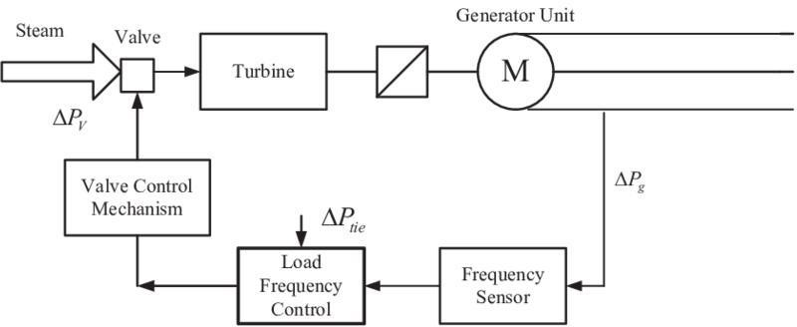

1. Give the control scheme for turbine speed control. Ans:

The steam turbine runs at a speed of 7000 t0 13000 RPM, and this speed is controlled by the Woodward governor, which is mechanical-hydraulic or electrical.

They all include a pilot valve, or controller, which modulates the turbine’s inlet

valve to keep the shaft speed on the set point.

The turbine speed measurement will be done from one or two proximity probes for speed control.

The speed PID control amplifier compares this signal to the speed setpoint to generate an output signal to the ratio/ limiter.

The speed control amplifier can also receive a programmable droop feedback signal to increase the stability of the system. This droop signal is proportional to the controller’s output signal or generator load in MW.

1. Point out the significance of oil cooling system. Ans:

An oil cooler is a separate, smaller radiator to an engine’s main radiator, which maintains an oil supply at a consistent, optimal temperature. Its purpose is to cool the oil passing through the coils, thus improving the engine and the transmission’s lifetime. They are situated in front of an engine’s cooling system.

1. List the types of cooling tower. Ans:

There are three main types of cooling towers that are defined by how water or air pass through them. These types include crossflow, counterflow, and hyperbolic.

There are also two varieties classified solely on airflow, known as induced draft and passive draft cooling towers.

1. Give the parameters to be measured and controlled in a turbine. Ans:

The key to plant safety and performance is the ability to accurately measure and track temperature, pressure, and flow. Information collected at specific measuring points can be used to:

Avoid Metallurgical Failures: Temperatures need to be maintained below the vessel’s melting point in order to avoid metallurgical failure. Too-high temperatures can also lead to creep deformation in the rotating blades.

Determine Efficiency and Performance :Performance engineers can calculate the efficiency of a compressor or turbine if they know the inlet and exit temperatures, as well as the flow rate at the nozzle. When a gas turbine exhaust is used as heat input to a steam cycle, engineers can also estimate the performance of the heat recovery steam generator (HRSG) by using the temperature and flow measurement of the gas turbine exhaust.

Detect Inefficiencies : High exhaust temperatures and flow changes can be symptoms of a compressor or turbine that is not operating as it should. If a flow measurement device picks up irregularities, the plant operator can perform a diagnostic to identify the underlying causes.

Calculate Residual Life :By tracking temperatures over time, engineers can see the temperature history of a component, such as a furnace tube. This history allows

them to calculate how much life the component has left and to plan maintenance and replacements.

In steam turbines, the following parameters are critical and are continuously monitored:

Barometric pressure

Steam and steam condensate’s flow rate, temperature, and pressure on:

* The cold reheat.
* The high pressure throttle.
* The hot reheat.
* Low pressure induction sections.
* Exhaust pressure.

Similarly, in gas turbines, the critical parameters routinely checked include:

* Temperature and flow of the exhaust gas.
* Pressure and temperature of ambient air.
* Temperature at the compressor inlet.
* Pressure and temperature of gas fuel. 95.Define blade velocity coefficient in turbine. Ans:

The blade velocity coefficient is ratio of relative velocity of steam at outlet tip of the blade to the relative velocity of steam at inlet tip of the blade.

1. Examine the forms of cooling apparatus employed in power plants. Ans:

Even though all thermoelectric plants use water to generate steam for electricity generation, not all plant cooling systems use water. There are three main methods of cooling:

* + **Once-through systems** take water from nearby sources (e.g., rivers, lakes, aquifers, or the ocean), circulate it through pipes to absorb heat from the steam in systems called condensers, and discharge the now warmer water to the local source. Once-through systems were initially the most popular

because of their simplicity, low cost, and the possibility of siting power plants in places with abundant supplies of cooling water.

* + **Wet-recirculating or closed-loop systems** reuse cooling water in a second cycle rather than immediately discharging it back to the original water source. Most commonly, wet-recirculating systems use cooling towers to expose water to ambient air. Some of the water evaporates; the rest is then sent back to the condenser in the power plant. Because wet-recirculating systems only withdraw water to replace any water that is lost through evaporation in the cooling tower, these systems have much lower water withdrawals than once-through systems, but tend to have appreciably higher water consumption.
  + **Dry-cooling systems** use air instead of water to cool the steam exiting a turbine. Dry-cooled systems use no water and can decrease total power plant water consumption by more than 90 percent. The tradeoffs to these water savings are higher costs and lower efficiencies. In power plants, lower efficiencies mean more fuel is needed per unit of electricity, which can in turn lead to higher air pollution and environmental impacts from mining, processing, and transporting the fuel.

99.Define speed ratio in turbine. Ans:

The Tip Speed Ratio (TSR) is an extremely important factor in wind turbine design.

TSR refers to the ratio between the wind speed and the speed of the tips of the wind turbine blades. TSR (λ) = If the rotor of the wind turbine spins too. Slowly, most of the wind will pass straight.

PART 1A

1. With Schematic diagram explain impulse turbine. Ans:

The most accessible type of turbine is an impulse turbine where a water jet from the penstock drives the rotor and colloids directly through the rotor blades. As the name suggests, this turbine works on the impulse force that is created to strike the blade of the water jet. This turbine includes major components like a set of blades & nozzles.

# Impulse Turbine Construction

The construction of an impulse turbine can be done by using different components. So impulse turbine components mainly include;

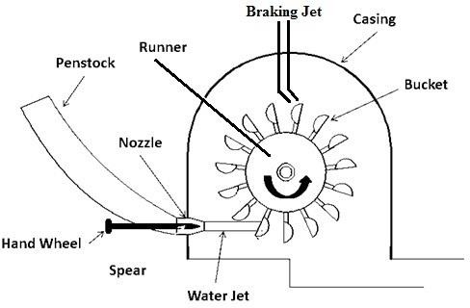

Penstock

The penstock of this turbine is a pipe or a channel, used to supply water to the impulse turbine. This penstock is very helpful in providing water from the reservoir to the turbine because the turbine is arranged at the downside whereas the reservoir is at the high end.

Nozzle

The main function of the nozzle is to provide the water supply to the impeller blades. Here, the water from the reservoir is supplied within a nozzle so that the water pressure energy can be changed into kinetic energy. Once this conversion is done, it supplies enhanced kinetic energy of water to the impeller blades where the water hits these blades.

Runner/Impeller

The shape of the runner in the turbine is a circular disk that is arranged on a revolving shaft which is called a rotor. The cup-shaped blades (buckets) are also arranged on the runner which is evenly curved.

Bucket

The Buckets are spoon or cup-shaped blades in a wind turbine which are arranged approximately at the edge of the runner so that energy can be exchanged in between the turbine & the water. The materials used to make these buckets are cast iron or stainless steel.

Casing

The casing of the turbine is a protection shield, made with cast iron. This shield is used to protect from water splatter & also directs the spillway channel so that water does not disperse. This shield also protects all the components of the turbine from the outside environment.

Braking Jet

Braking jets play a key role in avoiding the blades of the turbine after the water flow is turned off from the nozzle. The blades of the turbine will rotate even after the water supply is turned off. So, the blade of the turbine will strike from the reverse side of the blade to avoid the blade of the turbine from turning instantly.

Impulse Turbine Working

The impulse turbine works on the principle of Newton’s second law of motion. For these types of turbines, the water can be stored in reservoirs at high places & supplies throughout penstock to the turbine which is located at the ground. This turbine works in the following steps.

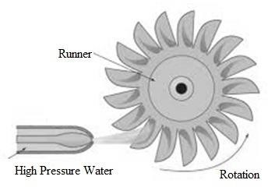

* A water jet moves from a dam or reservoir to the connected nozzles in the turbine.
* Once the water is supplied into the nozzle of the turbine, then it changes the energy of the pressure water into kinetic energy.
* After discharging throughout the nozzle, the water jet strikes the impeller blades & turns the impeller through its axis.
* These blades mainly change the kinetic energy (K.E) of the water jet into speed & enhance the water speed.
* The water with high speed hits the turbine so that shaft of the turbine starts turning.
* The shaft of the turbine is connected through the generator coil and the rotating motion of the shaft will rotate the generator coil.
* Once the generator coil starts turning, then it generates electricity and it delivers to different houses & industries.

1. Describe briefly various methods of steam turbine governing. Ans:

The methods used for governing the steam turbines are: 1. Throttle Governing 2. Nozzle-Control Governing 3. By-Pass Governing’s 4. Extraction Pressure Regulating System 5. Over-Speed Tripping System/Emergency Governor.

# Throttle Governing:

In this type of governing the steam is throttled down to lower pressure according to the load on the turbine before it is supplied to the turbine. It reduces the enthalpy drop i.e. the available energy of the steam. Such a method is useful for small capacity power plants since the mechanism is simple with initial low cost.

# Nozzle-Control Governing:

In this method, the first stage nozzles are split-up groups which are controlled by individual throttle valves. Various arrangements of valves and group of nozzles are employed. Three such arrangements are shown diagrammatically in the Fig.

20.8. An arrangement often adopted with large steam turbines using high- pressure steam is shown in Fig. 20.8(a). The number of nozzle groups may vary from three to five or more.

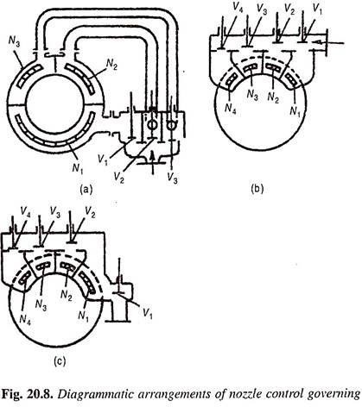

Figure 20.8(b) shown an arrangement where the nozzle control valves are arranged in a casting forming part of the cylinder of bolted thereto, and containing passes loading to individual nozzle groups. The nozzles are confined to upper half of the cylinder and are of admission is limited to 180° or less. The number of nozzle groups may vary from four to twelve.

# By-Pass Governing’s:

Modern steam power plants employing impulse turbines at very high pressure of steam at admission are usually designed to operate usually at an economical load which is bout 75-80% of the maximum load. In such cases -it is desirable to have full admission of steam in first few stages of the turbine operating at very high pressure since the enthalpy drop is very small in the initial stages and the nozzle governing cannot be used effectively.

Therefore the load regulation is achieved by throttle governing upto the stage of economical loads. However at the maximum loads the additional amount of steam required cannot be passed through the first-stages since the required

addi•tional number of nozzles is not available. This difficulty of steam regulation is overcome by employing by-pass governing.

Steam required upto economical loads are passed through the inlet valve and it is collected in the nozzle-chest. The governing is affected by throttle valve. However at loads more than economical load, the by-pass valve lifts and a part of the steam is by-passed into the steam belt and this steam mixes with the steam of high pressure turbine stages and it is supplied to lower stages of the turbine. This increases the power output of the turbine. The move•ment of the by-pass valve is controlled by the turbine governor.

# Extraction Pressure Regulating System:

Extraction pressure regulating system is used where steam at constant pressure is extracted for heating or process requirements from a condensing turbine which meets the power requirement. The control gear must be designed to maintain speed and pressure of extracted steam regardless of the variation in power and heating loads.

# Over-Speed Tripping System/Emergency Governor:

If a turbine has a not too satisfactory speed regulating system the sudden increase in the shaft speed at times of load tripping may reach dangerous figures. The usual over-speed limits is taken as about 10 to 12% of the normal operating speed. Hence every turbine is provided with one or two over-speed trips which shut off the supply of steam to the turbine if the r.p.m. exceeds a certain limit.

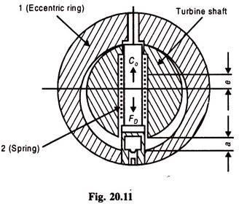

The over-speed tripping device consists of an unstable centrifugal governor (static regularity). Figure 20.11 shows the main details of construction of such a ring- type static regulator. The eccentric ring 1 is directly mounted on the turbine shaft.

The eccentric right is held in the position shown in Fig. 20.11 spring 2. The

eccentricity € of the regulator is given by the distance between the axis of the

turbine shaft and the center of gravity of the regulator ring 1.

Distance a shows the regulator travel. The regulator ring 1 is displaced through a when the shaft speed exceeds the limiting speed. Over-speed regulators are made of various different constructions as well.

Regulator pin 1, when over-speeding, trips lever 7 disconnecting the interlock 8. The tensile force of the helical spring rotates lever 2 and segment 3 in the clockwise direction. Segment 3 now leaves its notch in sleeve 4 and allows the valve to close under the pressure of its own spring 5, thus shutting off steam supply to the turbine.

If the stop valve is to be re-opened the following operations have to be carried out. The hand wheel of the stop valve is rotated in the direction of closing. During this operation sleeve 4 is displaced upward. Levers 7, 2 and segments 3 are now

brought back to their original position. The stop valve is opened by means of the hand-wheel.

4. Describe various cooling systems in turbine. Ans:

# Types of Turbine Cooling

**Air cooling methods** are used throughout the whole turbine arrangement. Turbine components are cooled using the air bled from the compressor. Stator blades and the outer wall of the turbine flow passage use cooling air routed between the combustor and the outer engine case, whereas turbine rotor blades, disks and the inner walls of the turbine flow passage use air that travels through the inner passage way. We’ll be taking a closer look at air cooling types used specifically on blades.

When talking about air cooling turbine blades, we can usually distinguish between two main types: **internal cooling and film and transpiration cooling.** The first type, internal cooling, maintains the blade metal temperature below the outside gas temperature by heat transfer to internal cooling air. This can include convection cooling and impingement cooling, where cooling air runs through channels within the blade. In the second type of cooling, film and transpiration cooling, the aim is to reduce heat transfer to the blades surface. This is done through film cooling, full-coverage film cooling and transpiration cooling. These methods can also be combined into a single blade for example by designing a blade with convection-, impingement- and film cooling.

**Turbine inlet air cooling** is a group of technologies and techniques consisting of cooling down the intake air of the gas turbine. The direct consequence of cooling the turbine inlet air is power output augmentation. It may also improve the energy efficiency of the system.

1. Classify various methods of compounding steam turbine. Ans:

Types of compounding

In an Impulse steam turbine compounding can be achieved in the following three ways:

* + Velocity compounding
  + Pressure compounding
  + Pressure-Velocity Compounding

In a reaction turbine compounding can be achieved only by pressure compounding.

The **velocity compounded Impulse turbine** was first proposed by C G Curtis to solve the problem of single stage Impulse turbine for use of high pressure and temperature steam.

The rings of moving blades are separated by rings of fixed blades. The moving blades are keyed to the turbine shaft and the fixed blades are fixed to the casing. The high pressure steam coming from the boiler is expanded in the nozzle first.

The Nozzle converts the pressure energy of the steam into kinetic energy. The total enthalpy drop and hence the pressure drop occurs in the nozzle. Hence, the pressure thereafter remains constant.

This high velocity steam is directed on to the first set (ring) of moving blades. As the steam flows over the blades, due to the shape of the blades, it imparts some of its momentum to the blades and loses some velocity. Only a part of the high kinetic energy is absorbed by these blades. The remainder is exhausted on to the next ring of fixed blade. The function of the fixed blades is to redirect the steam leaving from the first ring of moving blades to the second ring of moving blades. There is no change in the velocity of the steam as it passes through the fixed blades. The steam then enters the next ring of moving blades; this process is repeated until practically all the energy of the steam has been absorbed.

# Pressure compounding of Impulse Turbine

The pressure compounded Impulse turbine is also called as Rateau turbine, after its inventor. This is used to solve the problem of high blade velocity in the single- stage impulse turbine.

It consists of alternate rings of nozzles and turbine blades. The nozzles are fitted to the casing and the blades are keyed to the turbine shaft.

In this type of compounding the steam is expanded in a number of stages, instead of just one (nozzle) in the velocity compounding. It is done by the fixed blades which act as nozzles. The steam expands equally in all rows of fixed blade. The steam coming from the boiler is fed to the first set of fixed blades i.e. the nozzle ring. The steam is partially expanded in the nozzle ring. Hence, there is a partial decrease in pressure of the incoming steam. This leads to an increase in the velocity of the steam. Therefore, the pressure decreases and velocity increases partially in the nozzle.

This is then passed over the set of moving blades. As the steam flows over the moving blades nearly all its velocity is absorbed. However, the pressure remains constant during this process. After this it is passed into the nozzle ring and is again partially expanded. Then it is fed into the next set of moving blades, and this process is repeated until the condenser pressure is reached.

# Pressure-Velocity compounded Impulse Turbine

Is a combination of the above two types of compounding. The total pressure drop of the steam is divided into a number of stages. Each stage consists of rings of fixed and moving blades. Each set of rings of moving blades is separated by a single ring of fixed blades. In each stage there is one ring of fixed blades and 3-4 rings of moving blades. Each stage acts as a velocity compounded impulse turbine.

The fixed blades act as nozzles. The steam coming from the boiler is passed to the first ring of fixed blades, where it gets partially expanded. The pressure partially decreases and the velocity rises correspondingly. The velocity is absorbed by the following rings of moving blades until it reaches the next ring of fixed blades and the whole process is repeated once again.

# Pressure compounding of Reaction Turbine

A reaction turbine is one in which there is pressure and velocity loss in the moving blades. The moving blades have a converging steam nozzle. Hence when the steam passes over the fixed blades, it expands with decrease in steam pressure and increase in kinetic energy.

This type of turbine has a number of rings of moving blades attached to the rotor and an equal number of fixed blades attached to the casing. In this type of turbine the pressure drops take place in a number of stages.

The steam passes over a series of alternate fixed and moving blades. The fixed blades act as nozzles i.e. they change the direction of the steam and also expand it. Then steam is passed on the moving blades, which further expand the steam and also absorb its velocity.

1. Explain about free governor mode operation in detail. Ans:

All the turbo- generators in the grid participating in the governing action tend to annul the change in frequency by increasing or decreasing the generation. This mode of governor operation compensates the change in frequency by change in generation and is called Free Governor Mode of Operation (FGMO).

1. Describe briefly oil cooling system in turbine. Ans:

An oil cooler is a mechanical device that is used to remove surplus heat from internal combustion engines through a heat-exchanger. The device is used for cooling various mechanical parts using oil.

For cooling the turbine not only oil is used but also water is used between any relative moving bodies there is heat generated in order to remove the heat the coolers are used. standing outside a dam you can tell how many units are running.

1. Explain about turbine oil system with neat diagram. TURBINE OILING SYSTEM

OIL SUPPLY

A single oil supply line lubricates and cools the bearing, governs the m/c and operates the hydraulic actuators and safety and protective devices.

During start-up & shut-down, aux oil pump supplies the control oil. Once the turbine speed is more than 2850 rpm, the main oil pump (M.O.P) takes over. It draws oil from main tank .The lubricating oil passes through oil cooler, before can

be supplied to the bearing (Under emergency, lube oil can be supplied by a DC oil pump).Before the turbine is turned or barred, Jacking oil pump (2 nos.) supplies high pressure oil to the jack up the TG shaft to prevent boundary lubrication and also supplies high pressure oil to drive the hydraulic motor(turning gear).

Turbine lubricating oil system Function:

1. Provides a supply of oil to journal bearings to give an oil wedge as the shaft rotates. 2. Maintains the temperature of turbine bearings constant at the required level. 3. Provides a medium for hydraulically operating the governor gear and controlling the admission valves. 4. Provides for hydrogen cooled generators a sealing medium to prevent hydrogen leaking out along the shaft.

* + Main components
  + Main Oil Pump
  + Auxiliary Oil Pump
  + Emergency Oil Pump
  + Jacking Oil Pump
  + Main Oil Tank (MOT)
  + Centrifugal Main Oil Pump
  + This pump is located at the front bearing pedestal of the HP turbine.
  + It is coupled to the turbine rotor through a gear coupling.
  + When the turbine is running at a normal speed of 3000rpm, then the desired quantity of oil to the governing systems and the lubrication systems is supplied by this pump.

Auxiliary Oil Pump

* + Auxiliary Oil Pump can meet the requirements of lubrication system under emergency conditions
  + One stage vertical centrifugal pump driven by an A.C. electric motor.
  + It has radial impeller and volute casing.
  + The pump automatically takes over under interlock action whenever the oil pressure in the lubrication system fails below certain desired level.

Emergency Oil Pump

* + Emergency oil pump has been foreseen by as a back-up protection to AC driven standby oil pump.
  + This is a centrifugal pump, driven by DC electric motor.
  + This automatically cuts in whenever there is a failure of AC supply at power station

Jacking Oil Pump:

* + JOP ensures that there is no metal contact between a journaland the bearing.
  + Positive displacement pumps that provide high pressure supplyof oil under strategic journals of the turbo generator and oil liftsthe shaft slightly.
  + This greatly reduces the static friction and bearing wear.
  + The JOP can be stopped after the lubricating oil film isestablished between the shaft and bearings.
  + Pressure produced is 120 bars Main oil tank
  + The oil used for lubrication is stored in the Mai Oil Tank.
  + Capacity -20/32 m3.
  + The Main Oil Tank holds the oil inside the tank for a period longenough to ensure liberation of air from the oil.
  + Filters are located inside the tank to filter the oil during itsnormal course.
  + The oil tank is supported on a framed structure just below theturbine floor at the left hand side of the turbine.

1. Classify various burner management in detail.

Ans: The BMS can be used in industries like Oil and Gas, Power Generation, Chemical or any other process that uses an industrial burner, furnaces, boilers or other equipment that uses a flame.

The system can monitor flames with flame detectors; it manages igniters, burners and actuators, like shutdown valves. The Burner Management System can have the following functions:Inhibit start up when the conditions are not met.Monitor the burner to detect unsafe operating conditions. Protect against unsafe operating conditions. Shutdown interlocks when the sensors don’t detect the flame or detects unsafe operating conditions, the BMS signals the actuators to stops the flow of fuel to the burners, to inhibit the flames. In the industry there are 2 methods for implementing a BMS: Separated or integrated.

The separated method is the traditional method of implementing a safety instrumented system (SIS) and a basic control system (BPCS). The SIS and BPCS logic solver are separated in two separate equipments.

Also the workstations and the SCADA software for each other are separated. Both systems can communicate with each other using a bus and a common communication protocol.

The integrated method is a new method of implementing the solution. In this method the SIS and BPCS logic solver and workstations are on common equipment. The logic solver is a plc that respects the standards requested by the industry, like SIL3.

1. Explain in detail about burners for liquid fuels. Ans:

Liquid fuel burners include wick, pre-vaporizing, vaporizing, porous, and atomizing burner. Atomization technique can be used with different types of liquid fuels.

The most commonly used methods for atomizing liquid fuels are pressure, rotary, and twinfluid atomization. These methods classified into two categories based on the magnitude of the velocities of the liquid stream and the surrounding gas. In the first category, a liquid stream with a high velocity emerges into a quiescent or relatively slow-moving gas, as in pressure atomization and rotary atomization. In the second category, a relatively slow-moving liquid comes into contact of a stream of gas flowing at high velocity as in twin-fluid atomization.

1. Describe about burners for solid fuels. Ans:

Solid Fuel Burner means a small-scale solid fuel burning appliance, where combustion of the solid fuel occurs within a firebox, and where there may be a regulated supply of air to the fire. It includes (but is not limited to) indoor open fires, freestanding or built in wood burners, pellet burners, potbelly stoves and coal ranges, chip heaters, water heaters or central heating units, multi-fuel burners, and similar appliances. It excludes small-scale domestic devices for smoking food, any portable unflued heaters fueled by gas, alcohol or other liquid fuels, gas hobs or gas ranges used for cooking, and any fuel burning appliance installed in a boat, caravan or motor home.

1. Discuss about fluidized bed boiler with neat diagram. Ans:

# Fluidized Bed Combustion (FBC Boiler)

A bed of solid particles is said to be fluidized when the pressurized fluid (liquid or gas) is passed through the medium and causes the solid particles to behave like a fluid under certain conditions. Fluidization causes the transformation of the state of solid particles from static to dynamic.

Fluidized Bed Combustion is the ignition of a solid fuel under the conditions.

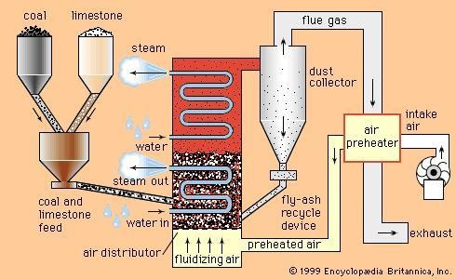

We, At Thermodynamic, Boiler Manufacture in India, We design and manufacture Boilers with

# Bubbling Fluidized Bed Combustion (BFBC) Circulating Fluidized Bed Combustion (CFBC).

Bubbling FBC is used for Fuels with lower heating values such as Rice Husk. Under such sort, the main factors leading to fluidization are as follows:

* Solid Fuel Particle Size
* Air Fuel Mixture

**Fluidized Bed Combustion** takes place when the forced draught fan supplies air to the Furnace of the Boiler. In the furnace, and is (used for Bubbling phenomenon) placed on the Bed and is heated before fluidization, the air enters the bed from

the nozzles fitted on the Furnace Bed. And above the nozzles; the sand opposes the upward motion of the air.

But at sufficient velocities, when the pressure applied by the air becomes equal to the weight of the sand, fluidization of the sand occurs.

Now the fuel supplied by fuel conveyor is fed to the preheated bubbling sand and gets combusted away. This phenomenon also ensures complete combustion of the Fuel.

The heat released during combustion heats up the surrounding boiler tubes and generates steam. The major advantages of Bubbling Fluidized Bed Combustion are the enhanced thermal efficiency, easy ash removal.

Another type is the Circulating Fluidized Bed Combustion; it is applied to fuels with higher heating values such as **Petcoke**.

In this, the unburned fuel is fed again to the furnace with the help of a Forced Draught fan and ducts, ensuring enhanced combustion and higher heating and provides excellent fuel flexibility.

Also, the fluidizing velocity of Air in CFBC is comparatively higher than that of BFBC. One of the major drawbacks is the power consumption.

The motors installed in the Forced Draught Fan consume more power than the one installed in the same capacity Boiler’s ( wood/coal fired) Forced Draught Fan, because of elevated levels of draught requirement to create fluidization.

17. Discuss air fuel ratio control in brief. Ans:

Air–fuel ratio (AFR) is the mass ratio of air to a solid, liquid, or gaseous fuel present in a combustion process. The combustion may take place in a controlled manner such as in an internal combustion engine or industrial furnace, or may result in an explosion (e.g., a dust explosion, gas or vapour explosion or in a thermobaric weapon).

The air–fuel ratio determines whether a mixture is combustible at all, how much energy is being released, and how much-unwanted pollutants are produced in the

reaction. Typically a range of fuel to air ratios exists, outside of which ignition will not occur. These are known as the lower and upper explosive limits.

19. Explain in detail about cyclone furnace with neat diagram. Ans:

A water-cooled horizontal cylinder in which fuel (coal, gas, or oil) is fired and heat is released at extremely high rates. When firing coal, the crushed coal is introduced tangentially into the burner at the front end of the cyclone (see illustration). About 15% of the combustion air is used as primary and tertiary air to impart a whirling motion to the particles of coal. The whirling, or centrifugal, action on the fuel is further increased by the tangential admission of high-velocity secondary air into the cyclone.

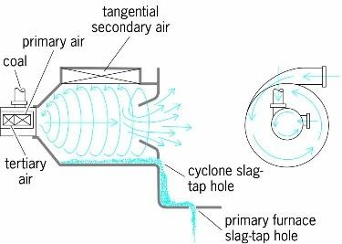

The products of combustion are discharged through a water-cooled re-entrant throat at the rear of the cyclone into the boiler furnace. Essentially, the fundamental difference between cyclone furnaces and pulverized coal—fired furnaces is the manner in which combustion takes place. In pulverized coal–fired furnaces, particles of coal move along with the gas stream; consequently, relatively large furnaces are required to complete the combustion of the suspended fuel. With cyclonic firing, the coal is held in the cyclone and the air is

passed over the fuel. Thus, large quantities of fuel can be fired and combustion completed in a relatively small volume, and the boiler furnace is used to cool the products of combustion. See Boiler, Steam-generating unit.

1. Explain the methods of measurement of combustion air flow Ans:

Two methods are available for measuring the air flow – static pressure characteristics: the air-duct measurement method via the pilot tube, and the double chamber measurement method.

Double chamber equipment is a measuring device with the highest level of general utility that may be used regardless of whether the fan is equipped with an intake or outlet tube.

Since this method allows the speed of the fluid flowing through the nozzle to be determined from the pressure differential between chambers A and B, the air flow (Q) can be expressed as a product of the flow speed (V) through the nozzle, the nozzle area (A), and the flow coefficient (C), as shown:

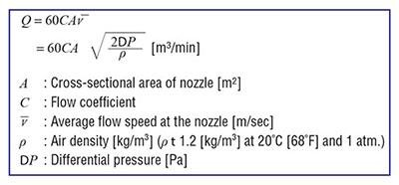

The measurement of air flow – static pressure characteristics uses an auxiliary blower to control the pressure in chamber B, altering the pressure in chamber A. Thus, each point on the characteristics curve can be measured.

1. List the two basic types of deaerators. Explain any one in detail. Ans:

There are two basic types of deaerators, the tray-type and the spray-type:

* + The tray-type (also called the cascade-type) includes a vertical domed deaeration section mounted on top of a horizontal cylindrical vessel which serves as the deaerated boiler feedwater storage tank.
  + The spray-type consists only of a horizontal (or vertical) cylindrical vessel which serves as both the deaeration section and the boiler feedwater storage tank.

The typical horizontal tray-type deaerator in Figure has a vertical domed deaeration section mounted above a horizontal boiler feedwater storage vessel. Boiler feedwater enters the vertical dearation section above the perforated trays and flows downward through the perforations. Low-pressure dearation steam enters the below the perforated trays and flows upward through the perforations.

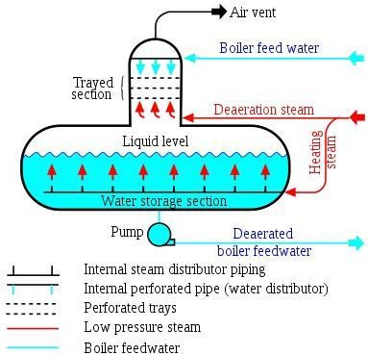

Some designs use various types of packing material, rather than perforated trays, to provide good contact and mixing between the steam and the boiler feed water.

The steam strips the dissolved gas from the boiler feedwater and exits via the vent at the top of the domed section. Some designs may include a vent condenser to trap and recover any water entrained in the vented gas. The vent line usually includes a valve and just enough steam is allowed to escape with the vented gases to provide a small and visible telltale plume of steam.

The deaerated waster flows down Into the horizontal storage vessel from where it is pumped to the steam generating boiler system. Low-pressure heating steam, which enters the horizontal vessel through a sparger pipe in the bottom of the vessel, is provided to keep the stored boiler feedwater warm. External insulation of the vessel is typically provided to minimize heat loss.

1. Analyze the need of Air/fuel ratio control? What is meant by the term Oxygen trim Control in Boiler? Explain the method of controlling the combustion by Oxygen trim Control

Ans:

In an internal combustion engine or industrial furnace, the air–fuel ratio is an important measure for anti-pollution and performance-tuning reasons. If exactly enough air is provided to completely burn all of the fuel, the ratio is known as the stoichiometric mixture, often abbreviated to stoich. Ratios lower than

stoichiometric are considered “rich”. Rich mixtures are less efficient, but may produce more power and burn cooler. Ratios higher than stoichiometric are considered “lean”. Lean mixtures are more efficient but may cause higher temperatures, which can lead to the formation of nitrogen oxides. Some engines are designed with features to allow lean-burn. For precise air–fuel ratio calculations, the oxygen content of combustion air should be specified because of different air density due to different altitude or intake air temperature, possible dilution by ambient water vapor, or enrichment by oxygen additions.

Oxygen trim (O2 Trim) is a system that constantly monitors your boiler’s combustion. This system can adjust your air fuel ratio based on what it’s supposed to be and triggers alarms or lockouts should the combustion deviate from proper levels. It also helps end users save on operational and maintenance costs.

An O 2 trim system consists of an exhaust- gas monitoring probe that communicates with the combustion air inlet damper via a central digital controller. Based on the O 2 level detected in the exhaust gas, the combustion air damper automatically adjusts to achieve a user-defined excess air set-point. To optimize combustion efficiency over a boiler’s firing range, the O 2 set-point should be set to 1.7%, which corresponds to 10% excess air which provide highest combustion efficiency. Rather than be linked by a jackshaft as in single-point positioning, the fuel valve and combustion air damper are controlled indepen- dently in O 2 trim control. The minimum amount of air required for complete combustion is called the “stoichiometric” air.

1. Explain the flue gas dew point control. Ans:

The flue gas dew point is a critical parameter for in-situ optical dust sensors like transmissometers and scatter light type. Such devices are not able to differentiate between water droplets or acid mist from the dust particles; and so, they are unable to give a representative dust reading. Therefore, alternative methods should be considered for dust concentration measurement under condensing gas conditions.

Most of the in-situ gas analysers are also not suitable for condensing gas application due to the highly corrosive atmosphere that will attack probes and optical elements of the sensor.

The high dew points of different chemical compounds (complex hydrocarbons, salts etc) that can be present in the flue gas require specialised sample probes, with forced condensation, or selection of a system that is able to maintain sampled gas temp at above the all dew points.

Cooling of the flue gas can be performed either directly with a heat exchanger or indirectly via a condensing scrubber.

The condensation of water releases more than 2 gigajoules (560 kWh) per ton of condensed water, which can be recovered in the cooler for e.g. district heating purposes.Excess condensed water must continuously be removed from the process.

The downstream gas is saturated with water, so even though significant amounts of water may have been removed from the cooled gas, it is likely to leave a visible stack plume of water vapour.

The heat recovery potential of flue gas condensation is highest for fuels with a high moisture content (e.g. biomass and municipal waste), and where heat is useful at the lowest possible temperatures. Thus flue gas condensation is normally implemented at biomass fired boilers and waste incinerators connected district heating grids with relatively low return temperatures (below approximately 55 °C (131 °F)).

1. Discuss about Steam temperature control in detail. Ans:

The temperature of saturated steam is directly related to its pressure, so tighter control of temperature, elimination of PID requirement and less temperature drift is easily achieved using a steam pressure regulator. Simply put: If you control the pressure of saturated steam, you can control the temperature.

1. Explain the working of dissolved oxygen analyzer used in feed water analysis. Ans:

Dissolved oxygen refers to oxygen dissolved in water. Its concentration is expressed as the amount of oxygen per unit volume and the unit is mg/L. Biologically, oxygen is an essential element for respiration of underwater life and also acts as a chemical oxidizer. The solubility of oxygen in water is affected by water temperature, salinity, barometric pressure, etc. and decreases as water temperature rises.

The membrane electrode method measures a diffusion current or reduction current generated by the concentration of dissolved oxygen or partial pressure of oxygen to obtain the concentration of dissolved oxygen. This method is not affected by the pH value of water being measured, oxidation and reduction substances, color, turbidity, etc. and the measurement method offers good reproducibility.

When a sensor is inserted into water, an air layer forms on the membrane (Teflon membrane). The oxygen partial pressure (concentration) in the air layer is in

equilibrium with the concentration of dissolved oxygen in the water. The membrane electrode method measures the oxygen concentration in the gas phase to indirectly obtain the concentration of dissolved oxygen in water.

1. With suitable diagram, explain the principle of Electromagnetic type flow meters. Also mention Its advantages and limitations.

Ans:

Electromagnetic Flow Meters are based on FARADAY’S LAW OF INDUCTION. These meters are also called as Magflow or Electromagnetic Flow Meters. A magnetic field is applied to the metering tube, which results in a potential difference proportional to the flow velocity perpendicular to the flux lines. The physical principle at work is electromagnetic induction and mathematically defined as E=k*B*D*V.

The Induced voltage is directly proportional to the velocity (V) of the fluid moving through the magnetic field (B). The induced voltage is carried to the transmitter through the electrode circuit. The transmitter then converts this voltage into a quantifiable flow velocity. The volumetric flow rate of the fluid is calculated using this known velocity along with the area of the pipe.

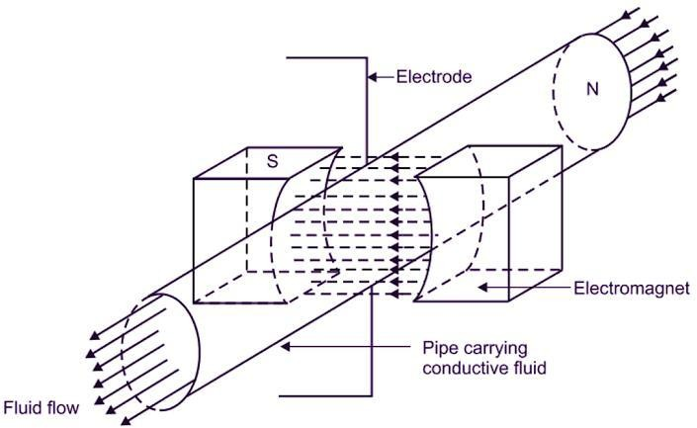

When a flowmeter is installed and activated, its operations begin with a pair of charged magnetic coils. As energy passes through the coils, they produce a magnetic field that remains perpendicular to both the conductive fluid being measured and the axis of the electrodes taking measurements. The fluid moves along the longitudinal axis of the flowmeter, making any generated induced voltage perpendicular to the field and the fluid velocity. An increase in the flow rate of the conductive fluid will create a proportionate increase the voltage level.

The meter features flanged construction and Is available with choice of liner and electrode material. All meters consist of a sensor and a converter that may be mounted integral to the sensor or remotely either with a field mount kit.

Advantages of electromagnetic flow meter which are given below,the electromagnetic flow meter provides rapid response to flow changes.

* It provides linear wide range.
* Measuring range setting can be optimized.
* It has ability to measure reverse flow.
* No additional pressure drops.
* No obstruction is created to flow.
* It is mainly suitable for hydraulic solid transport.
* It is unaffected by changes in temperature, density, viscosity, concentration and electrical conductivity.

Disadvantages of electromagnetic flow meter which are given below,

* It is not suitable for low velocity.
* It is more expensive.
* It is suitable for fluids having conductivity greater than 20 micro ohm/cm.
* Gas inclusion cause errors.

34. Classify the transducers based on Low, Medium and High temperature applications? Also list The major temperature measurement points and suggest suitable sensors in Thermal power Plant.

Ans:

Temperature Sensor Types

Negative Temperature Coefficient (NTC) thermistor

A thermistor is a thermally sensitive resistor that exhibits a continuous, small, incremental change in resistance correlated to variations in temperature. An NTC thermistor provides higher resistance at low temperatures. As temperature increases, the resistance drops incrementally, according to its R-T table. Small changes reflect accurately due to large changes in resistance per °C. The output of an NTC thermistor is non-linear due to its exponential nature; however, it can be linearized based on its application. The effective operating range is -50 to 250 °C for glass encapsulated thermistors or 150°C for standard thermistors.

Resistance Temperature Detector (RTD)

A resistance temperature detector, or RTD, changes the resistance of the RTD element with temperature. An RTD consists of a film or, for greater accuracy, a wire wrapped around a ceramic or glass core. Platinum makes up the most accurate RTDs while nickel and copper make RTDs that are lower cost; however, nickel and copper are not as stable or repeatable as platinum. Platinum RTDs offer a highly accurate linear output across -200 to 600 °C but are much more expensive than copper or nickel.

Thermocouples

A thermocouple consists of two wires of different metals electrically bonded at two points. The varying voltage created between these two dissimilar metals reflects proportional changes in temperature. Thermocouples are nonlinear and require a conversion with a table when used for temperature control and compensation, typically accomplished using a lookup table. Accuracy is low, from

0.5 °C to 5 °C but thermocouples operate across the widest temperature range, from -200 °C to 1750 °C.

Semiconductor-based temperature sensors

A semiconductor-based temperature sensor is usually incorporated into integrated circuits (ICs). These sensors utilize two identical diodes with temperature-sensitive voltage vs current characteristics that are used to monitor changes in temperature. They offer a linear response but have the lowest accuracy of the basic sensor types. These temperature sensors also have the

slowest responsiveness across the narrowest temperature range (-70 °C to 150

°C).

1. Describe ultimate and proximate analysis of a fuel. Ans:

**Ultimate analysis** is useful during mass balance calculations for a chemical or thermal process. Ultimate analysis of waste is carried out to determine the proportions of carbon, hydrogen, oxygen, nitrogen and sulphur.

The ash fraction should also be determined because of its potentially-harmful environmental effects, brought about by the presence of toxic metals-cadmium, chromium, mercury, nickel, lead, tin and zinc.

Other metals, such as iron, manganese, calcium, magnesium and sodium are also present but because they are not toxic, they do not present a serious problem.

**Proximate analysis** is important in evaluating the combustion properties of waste or waste derived fuel. The fractions of greatest interest are: moisture content, ash, volatile matter and fixed carbon

Moisture adds weight to the waste fuel without increasing its heating value and the evaporation of water reduces the heat released from the fuel. Ash also adds weight without releasing any heat during combustion.

Volatile matter is that portion of the waste that is converted to gas before and during combustion and fixed carbon represents the carbon remaining on the surface of grates as char. High proportion of fixed carbon requires longer retention time to achieve complete combustion.

1. Describe the working of gas chromatography for the analysis of fuel gas with a neat sketch.

Ans:

Gas chromatography is the process of separating compounds in a mixture by injecting a gaseous or liquid sample into a mobile phase, typically called the carrier gas, and passing the gas through a stationary phase. The mobile phase is usually an inert gas or an unreactive gas such as helium, argon, nitrogen or hydrogen. The stationary phase is a microscopic layer of viscous liquid on a

surface of solid particles on an inert solid support inside a piece of glass or metal tubing called a column. The surface of the solid particles may also act as the stationary phase in some columns. The glass or metal column through which the gas phase passes is located in an oven where the temperature of the gas can be controlled and the eluent coming off the column is monitored by a computerized detector.

A gas chromatograph is made of a narrow tube, known as the column, through which the vaporized sample passes, carried along by a continuous flow of inert or nonreactive gas. Components of the sample pass through the column at different rates, depending on their chemical and physical properties and the resulting interactions with the column lining or filling, called the stationary phase. The column is typically enclosed within a temperature controlled oven. As the chemicals exit the end of the column, they are detected and identified electronically.

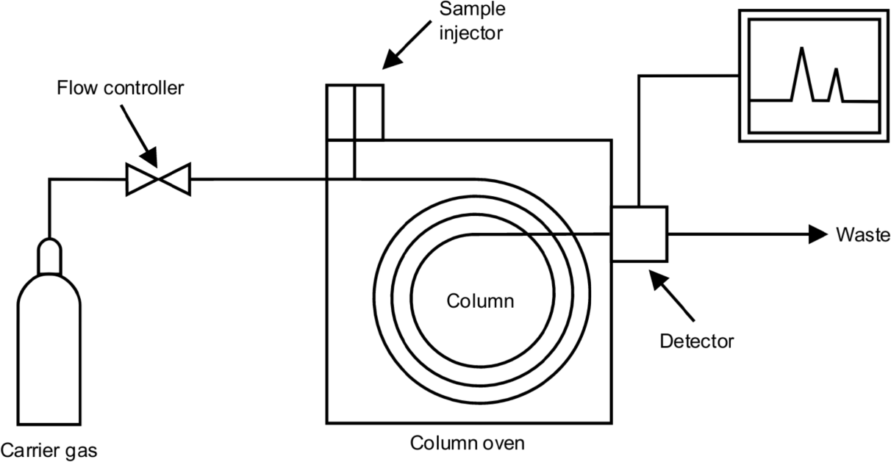

1. Discuss the operation of LP and HP heaters in power plant. Ans:

In regenerative feed heating system, the steam supplied by the boiler, is not expanded in turbine totally, to get useful work. On the contrary, certain amount

of steam is always extracted from different stages of turbine (preferable from MP & LP turbine) to heat the condensate / feed water. Thus the thermal energy of the extracted steam is recovered. This will result in improvement in thermal efficiency of cycle by 3-4%, when compared with a conventional rankine cycle.

In such system around 6 nos LP Heaters and 2-3 nos HP Heaters are incorporated in the circuit of 110MW & 210MW BHEL unit.

In 110MW unit, because of feed heating system, the condensate is heated from 50 degree centigrade( hotwell temperature) to 220 degee centigrade( HP Heater outlet temperature) without burning any extra fuel. Therefore the amount of “fuel” required to be burnt to increase the working fluid temperature from 220 degee centigrade to 540 degree centigrade , would be less than what it should be without heaters, where the condensate is supposed to be heated from 50 degree centigrade to 540 degree centigrade . Naturally it causes a fuel economy.

Moreover the “condenser loss” gets reduced as 20 -30% of total steam would be extracted from different stages of turbine causing a reduction of main steam flow, available in a conventional regenarative feedheating cycle. Lower the steam flow

in condenser will result in reduction of “condenser loss”.

Furthermore, reduction in “steam flow” in surface condenser, will help us in providing smaller size condenser. Similarly, because of less volume of steam, LP turbine blade height will also gets reduced thereby. This will make the system

economic and competitive.Mostly 5 nos “indirect contact heaters” & one number

“direct contact heater” are used in 110MW & 210MW BHEL unit.

Normally the heaters which are placed before the boiler feed pump are called as LP Heaters, whereas the Heaters which are placed after the boiler feed pump are called as HP Heaters. In LP Heaters, heat transfer takes place at its sub-cooling zone & condensing zones, but in HP Heaters an additional zone called as de- superheating zone is also available. This will result in better “terminal

temperature difference (TTD)”, sometime it may even be negative, which is the reflection of better performance of heat exchangers.

In steam power plants high pressure heaters are used to heat feed water. A portion of steam called bleed .Steam, that extracted from turbine is used in high pressure heaters to heat feed water, latent heat of this bleed steam is utilized

otherwise it will lost in condenser with cooling water. Hence over all cycle efficiency of the plant increased. In power plants H.P Heaters are connected in feed water line (Line between boiler feed pump and economiser).

1. Combine Primary and Secondary transducers in Pressure measurement? Explain the pressure measurement of steam in Power plant.

Ans:

The primary transducer or sensor is the element that is in contact with the pressure pulse, and generally is a displacement transducer, which transduces the pressure wave into a mechanical displacement.

Manometers and elastic element sensors are used as primary pressure sensors while secondary sensing, often called transducing here, involves resistive, inductive and capacitive changes for deriving electrical outputs.

Pressure measurement is the measurement of an applied force by a fluid (liquid or gas) on a surface. Pressure is typically measured in units of force per unit of surface area. Many techniques have been developed for the measurement of pressure and vacuum. Instruments used to measure and display pressure mechanically are called pressure gauges, vacuum gauges or compound gauges (vacuum & pressure). The widely used Bourdon gauge is a mechanical device, which both measures and indicates and is probably the best known type of gauge.

1. Design a combined Heat and Power System in brief. Ans:

Combined heat and power (CHP), also known as cogeneration, is:

The concurrent production of electricity or mechanical power and useful thermal energy (heating and/or cooling) from a single source of energy.

A type of distributed generation, which, unlike central station generation, is located at or near the point of consumption.

A suite of technologies that can use a variety of fuels to generate electricity or power at the point of use, allowing the heat that would normally be lost in the power generation process to be recovered to provide needed heating and/or cooling.

CHP technology can be deployed quickly, cost-effectively, and with few geographic limitations. CHP can use a variety of fuels, both fossil- and renewable- based. It has been employed for many years, mostly in industrial, large commercial, and institutional applications. CHP may not be widely recognized outside industrial, commercial, institutional, and utility circles, but it has quietly been providing highly efficient electricity and process heat to some of the most vital industries, largest employers, urban centers, and campuses in the United States. It is reasonable to expect CHP applications to operate at 65-75% efficiency, a large improvement over the national average of about 50% for these services when separately provided.

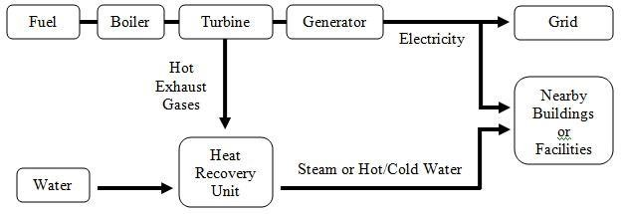

1. Describe Solar power plant with neat sketch. Ans:

A solar power plant is based on the conversion of sunlight into electricity, either directly using photovoltaics (PV), or indirectly using concentrated solar power (CSP). Concentrated solar power systems use lenses, mirrors, and tracking systems to focus a large area of sunlight into a small beam. Photovoltaics converts light into electric current using the photoelectric effect.

The solar power plant is based on the conversion of sunlight into electricity. As the use of solar energy has been increased nowadays. Not only we save the electricity with the help of a solar power plant but it also contributes towards the environment. It converts solar energy into electricity either directly using photovoltaics.

It Is in great use as it is least expensive and provides electricity with sunlight. The utilization of these products is increasing day by day after knowing the importance of solar energy use. The government is also taking initiatives to aware the people about solar products by introducing incentive schemes.

Installing solar power plant is quite beneficial in every aspect not only your pocket but the entire globe. This solar equipment is used in an active manner and converts the solar energy into a useable form which can be used for powering all sort of appliances.

Concentrated solar power system use mirrors, lenses and tracking systems to focus a large area of sunlight into a small beam. The photoelectric effect coverts the light into electric current. All the countries all over the globe have decided to bring the solar products into great use.

As everyone is aware nowadays to contribute towards the globe, our environment with the help of solar energy. Apart from this, it is a one-time investment and there will no longer need to spend on heavy electricity cost again and again.

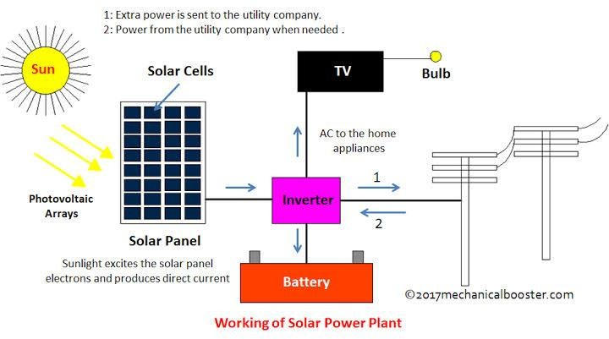

1. Explain with a neat sketch the process of electric power generation using wind energy.

Ans:

Wind turbines work on a simple principle: instead of using electricity to make wind like a fan wind turbines use wind to make electricity. Wind turns the propeller-like blades of a turbine around a rotor, which spins a generator, which creates electricity.

A wind turbine turns wind energy into electricity using the aerodynamic force from the rotor blades, which work like an airplane wing or helicopter rotor blade. When wind flows across the blade, the air pressure on one side of the blade decreases. The difference in air pressure across the two sides of the blade creates both lift and drag. The force of the lift is stronger than the drag and this causes the rotor to spin. The rotor connects to the generator, either directly (if it’s a direct drive turbine) or through a shaft and a series of gears (a gearbox) that speed up the rotation and allow for a physically smaller generator. This translation of aerodynamic force to rotation of a generator creates electricity.

Collection and transmission network In a wind farm, individual turbines are interconnected with a medium voltage (usually 34.5 kV) power collection system and communications network. At a substation, this medium-voltage electric current is increased in voltage with a transformer for connection to the high voltage electric power transmission system. A transmission line is required to bring the generated power to (often remote) markets. For an offshore station, this may require a submarine cable. Construction of a new high voltage line may be too costly for the wind resource alone, but wind sites may take advantage of lines already installed for conventional fuel generation. Wind power resources are not always located near to high population density. As transmission lines become longer the losses associated with power transmission increase, as modes of losses at lower lengths are exacerbated and new modes of losses are no longer negligible as the length is increased, making it harder to transport large loads over large distances. When the transmission capacity does not meet the generation capacity, wind farms are forced to produce below their full potential or stop running altogether, in a process known as curtailment. While this leads to potential renewable generation left untapped, it prevents possible grid overload or risk to reliable service. One of the biggest current challenges to wind power grid integration in some countries is the necessity of developing new transmission

lines to carry power from wind farms, usually in remote lowly populated areas due to availability of wind, to high load locations, usually on the coasts where population density is higher. Any existing transmission lines in remote locations may not have been designed for the transport of large amounts of energy. In particular geographic regions, peak wind speeds may not coincide with peak demand for electrical power, whether offshore or onshore. A possible future option may be to interconnect widely dispersed geographic areas with an HVDC super grid. Distinguish between sub critical and supercritical boilers with example.

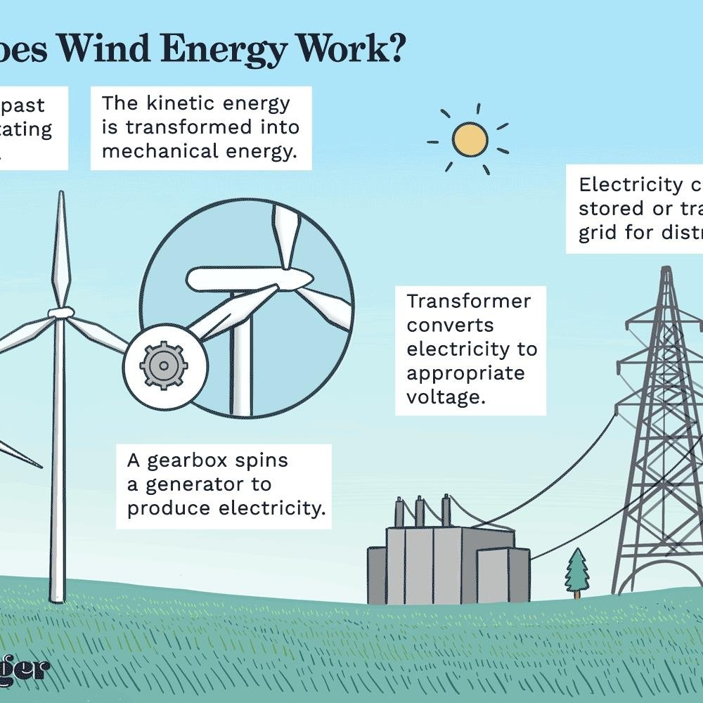

1. Distinguish between sub critical and supercritical boilers with example. Ans:

Subcritical boilers are boilers that work at temperatures up to 374°C and at a pressure of 3,208 psi (the critical point of water). Supercritical boiler (supercritical steam generator) is a type of boiler that works under supercritical pressure conditions. Subcritical boilers are operated at temperatures up to 374°C.

Water with pressure and heat first reach saturated temperature , then the steam is wet which further gets dry and then superheat. With higher pressure latent heat gets lesser and lesser. At about 225 kg/cm2 pressure latent heat become zero and water transform directly to superheated steam. So below this citical pressure it is subcritical and above 225 it is supercritical. Boilers generating steam above 225 kg are supercritical boilers. Accordingly boilers are designed. Higher the steam pressure lesser the volume which would save piping, turbine volume thereby saving equipment weights and costs.

1. List the applications of cogeneration in power plant and Label the PI diagram of cogeneration Plant

Ans:

Cogeneration is a more efficient use of fuel or heat, because otherwise-wasted heat from electricity generation is put to some productive use. Combined heat and power (CHP) plants recover otherwise wasted thermal energy for heating. This is also called combined heat and power district heating. Small CHP plants are an example of decentralized energy. By-product heat at moderate temperatures (100–180 °C, 212–356 °F) can also be used in absorption refrigerators for cooling.

The supply of high-temperature heat first drives a gas or steam turbine-powered generator. The resulting low-temperature waste heat is then used for water or space heating. At smaller scales (typically below 1 MW), a gas engine or diesel engine may be used. Cogeneration is also common with geothermal power plants as they often produce relatively low grade heat. Binary cycles may be necessary to reach acceptable thermal efficiency for electricity generation at all.

Cogeneration was practiced in some of the earliest installations of electrical generation. Before central stations distributed power, industries generating their

own power used exhaust steam for process heating. Large office and apartment buildings, hotels, and stores commonly generated their own power and used waste steam for building heat. Due to the high cost of early purchased power, these CHP operations continued for many years after utility electricity became available.

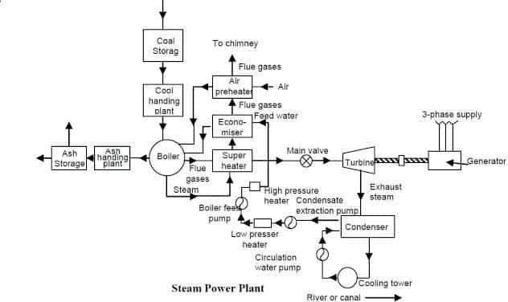

1. With schematic diagram explain Hydro Power plant generation. Ans:

The dam Is constructed across a river or lake and water from the catchment area collects at the back of the dam to form a reservoir.A pressure tunnel is taken off from the reservoir and water brought to the valve house at the start of the penstock.

The valve house contains main sluice valves and automatic isolating valves.The former controls the water flow to the power house and the latter cuts off the supply of water when the penstock bursts.From the valve house, water is taken to water turbine through a huge steel pipe known as penstock.The water turbine

converts hydraulic energy into mechanical energy.The turbine drives the alternator which converts mechanical energy into electrical energy.

A surge tank (open from top) is built just before the valve house and protects the penstock from bursting in case the turbine gates suddenly closed due to electrical

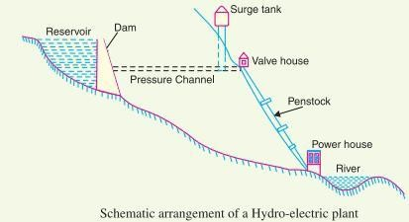

load being thrown off.When the gates close, there is a sudden stopping of water at the lower end of the penstock and consequently, he penstock can burst like a paper log.The surge tank absorbs this pressure swing by increase in its level of water.

The constituents of a hydro electric plant are

* Hydraulic structures
* Water turbines and
* Electrical equipment
  1. Hydraulic structures : Hydraulic structures in a hydro electric power station include dam, spillways, headworks, surge tank, penstock and accessory works.
     1. Dam : A dam is a barrier which stores water and creates water head.Dams are built of concrete or stone masonary, earth or rock fill.The type and arrangement depends upon the topography of the site.A masonary dam may be built in a narrow canyon. An

earth dam may be best suited for a wide valley. The type of dam also depends upon the foundation conditions, local materials and transportation available, occurrence of earthquakes and other hazards.At most of sites, more than one type of dam may be suitable and the one which is most economical is chosen.

* + 1. Spillways : There are times when the river flow exceeds the storage capacity of the reservoir.Such a situation arises during heavy rainfall in the catchment area.In order to discharge the surplus water from the storage reservoir into the river on the down-stream side of the dam, spillways are used.Spillways are constructed of concrete piers on the top of the dam.Gates are provided between these piers and surplus water is discharged over the crest of the dam by opening these gates.
    2. Headworks : The headworks consists of the diversion structures at the head of an intake.They generally include booms and racks for diverting floating debris, sluices for by-passing debris and sediments and valves for controlling the flow of water to the turbine.The flow of water into and through headworks should be as smooth as possible to avoid head loss and cavitation.For this purpose, it is necessary to avoid sharp corners and abrupt contractions or enlargements.
    3. Surge tank : Open conduits leading water to the turbine require no protection.However, when closed conduits are used, protection becomes necessary to limit the abnormal pressure in theconduit.For this reason, closed conduits are always provided with a surge tank.A surge tank is a small reservoir or tank (open at the top) in which water level rises or falls to reduce the pressure swings in the conduit.

A surge tank is located near the beginning of the conduit.When the turbine is running at a steady load, there are no surges in the flow of water through the conduit i.e., the quantity of water flowing in the conduit is just sufficient to meet the turbine requirements. However, when the load on the turbine decreases, the governor closes the gates of turbine, reducing water supply to the turbine.The

excess water at the lower end of the conduit rushes back to the surge tank and increases its water level.

Thus the conduit is prevented from bursting.On the other hand, when load on the turbine increases, additional water is drawn from the surge tank to meet the increased load requirement.Hence, a surge tank overcomes the abnormal pressure in the conduit when load on the turbine falls and acts as a reservoir during increase of load on the turbine.

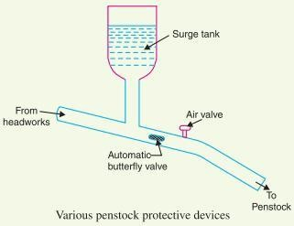

Hydro Electric Power Plant – Construction Working

* + 1. Penstocks : Penstocks are open or closed conduits which carry water to the turbines.They are generally made of reinforced concrete or steel.Concrete penstocks are suitable for low heads (< 30 m) as greater pressure causes rapid deterioration of concrete.The steel penstocks can be designed for any head; the thickness of the penstock increases with the head or working pressure.

Various devices such as automatic butterfly valve, air valve and surge tank are provided for the protection of penstocks.Automatic butterfly valve shuts off water flow through the penstock promptly if it ruptures.Air valve maintains the air pressure inside the penstock equal to outside atmospheric pressure.When water runs out of a penstock faster than it enters, a vacuum is created which may cause the penstock to collapse.Under such situations, air valve opens and admits air in the penstock to maintain inside air pressure equal to the outside air pressure.

* 1. Water turbines : Water turbines are used to convert the energy of falling water into mechanical energy.The principal types of water turbines are :
     1. Impulse turbines
     2. Reaction turbines
        1. Impulse turbines : Such turbines are used for high heads.In an impulse turbine, the entire pressure of water is converted into kinetic energy in a nozzle and the velocity of the jet drives the wheel.The example of this type of turbine is the Pelton wheel.It consists of a wheel fitted with elliptical buckets along its periphery.The force of water jet striking the buckets on the wheel drives the turbine.

The quantity of water jet falling on the turbine is controlled by means of a needle or spear (not shown in the figure) placed in the tip of the nozzle.The movement of the needle is controlled by the governor.If the load on the turbine decreases, the governor pushes the needle into the nozzle, thereby reducing the quantity of water striking the buckets.Reverse action takes place if the load on the turbine increased.

Hydro Electric Power Plant – Construction Working

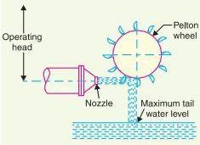

Pelton wheel

* + - 1. Reaction turbines: Reaction turbines are used for low and medium heads. In a reaction turbine, water enters the runner partly with pressure energy and partly with velocity head. The important types of reaction turbines are
         1. Francis turbines
         2. Kaplan turbines

A Francis turbine is used for low to medium heads.It consists of an outer ring of stationary guide blades fixed to the turbine casing and an inner ring of rotating blades forming the runner.The guide blades control the flow of water to the turbine.Water flows radially inwards and changes to a downward direction while passing through the runner.As the water passes over the “rotating blades” of the runner, both pressure and velocity of water are reduced.This causes a reaction force which drives the turbine.

Hydro Electric Power Plant – Construction Working

A Kaplan turbine is used for low heads and large quantities of water.It is similar to Francis turbine except that the runner of Kaplan turbine receives water axially.Water flows radially inwards through regulating gates all around the sides, changing direction in the runner to axial flow.This causes a reaction force which drives the turbine.

* 1. Electrical equipment: The electrical equipment of a hydro electric power station includes alternators, transformers, circuit breakers and other switching and protective devices.